Account creation
Menu: Common Data < G/L Accounting tables < General < G/L Accounts
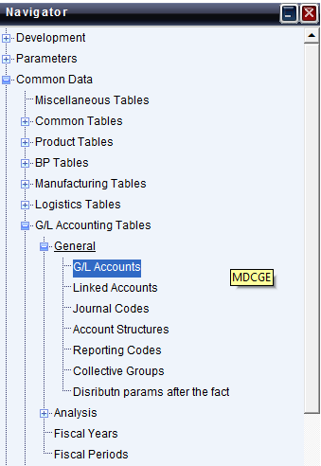
Press New to create accounts
Normal:
Collective: Auxiliary accounts

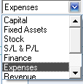
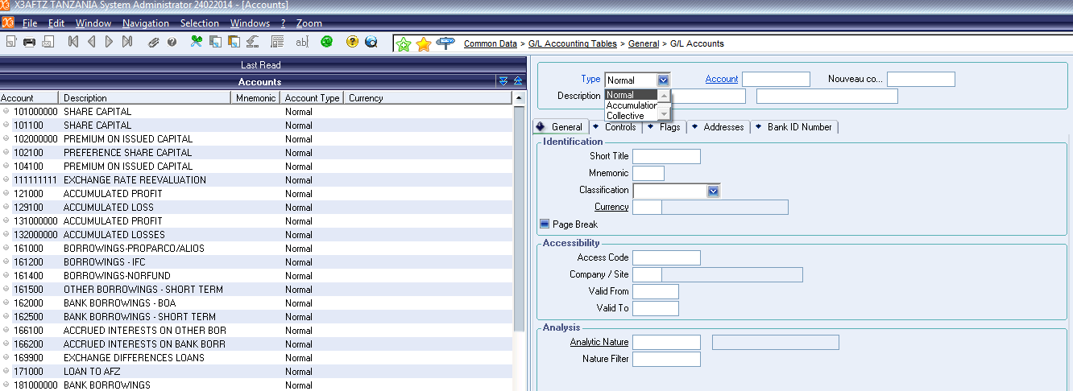
Account description
Account number on 9 digits
Account type
After that, we have to precise if the account is subjected or not to VAT :

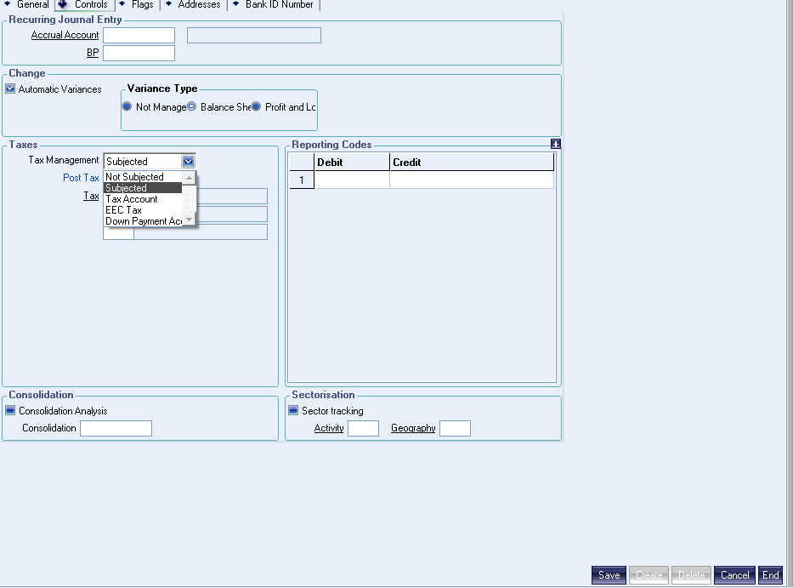
Subjected / Not subjected
And at last, we create and save the creation
Journal creation:
Menu: Common Data < G/L Accounting tables < General < Journal codes
Journal code
After creation, you have to activate the journal
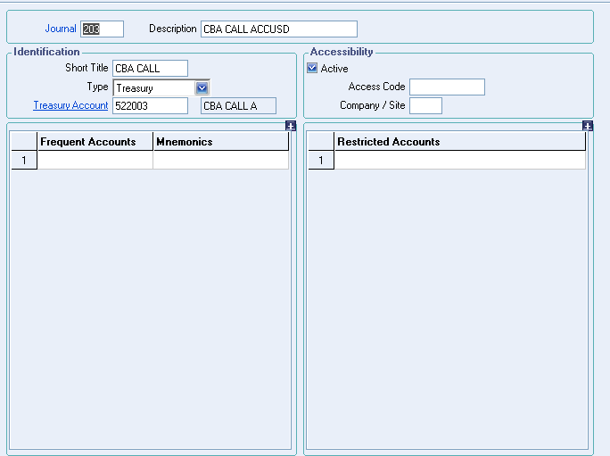
If it’s a treasury journal you have to put the corresponding account

