P
reamble :
All accounting entries recorded automatically (invoice posting, depreciation expenses, cash receipts, payments posting, etc.) are placed in a temporary table of the database, and a batch process steered by this function passes them in accounting. The same happens for all matching operations.
Therefore, it seems for users that the journal entries were not recorded, and it looks like an anomaly.
This guideline shows the different steps to follow in such cases:

- Check the accounting journal status monitor :
Link: Usage < Batch server < Journal Status Monitor
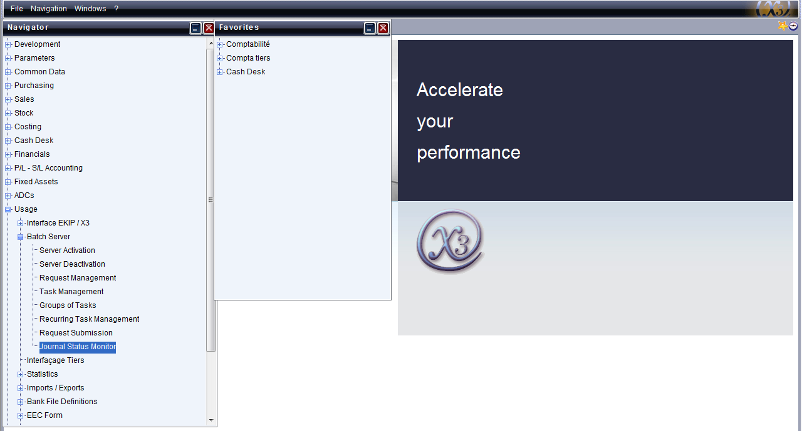
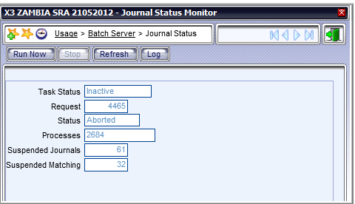
Pending maching
Pending journal entries

- Activate the batch server
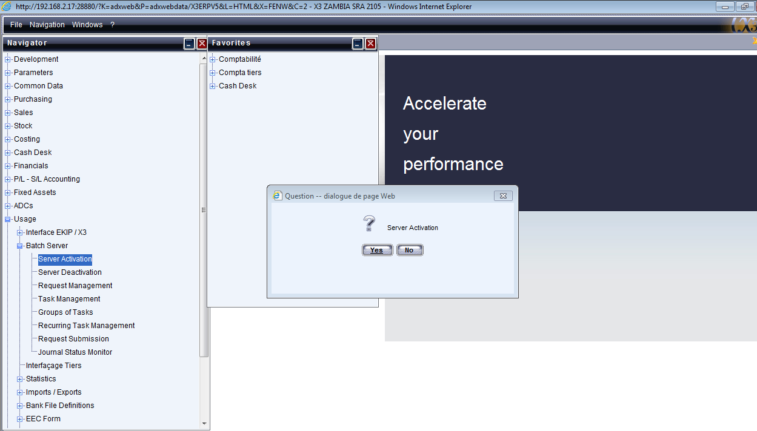

If the server is already active, you will get this notification as shown below:
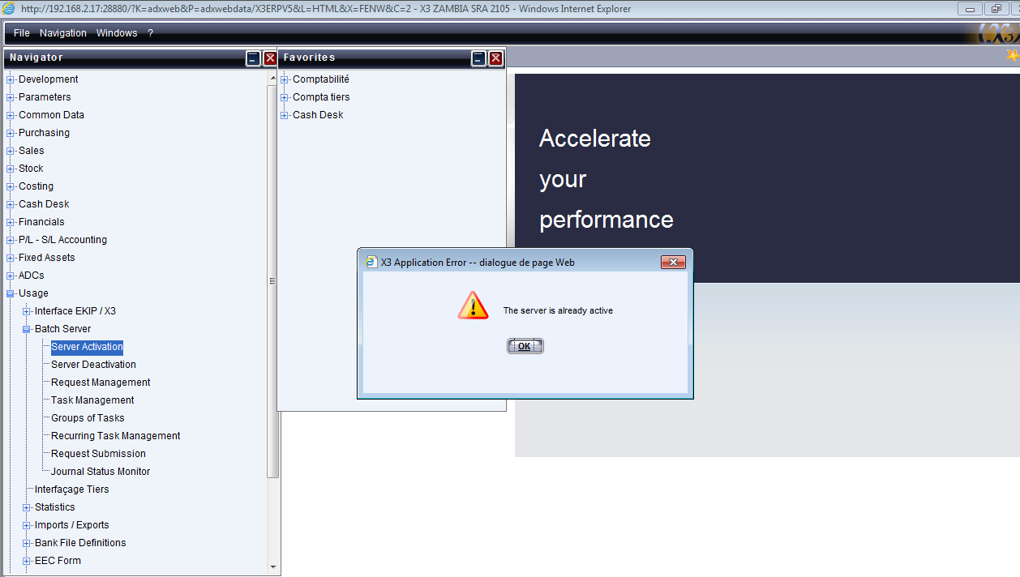

- Démarrer la tâche comptable
When the server is active, the batch server has to be run again

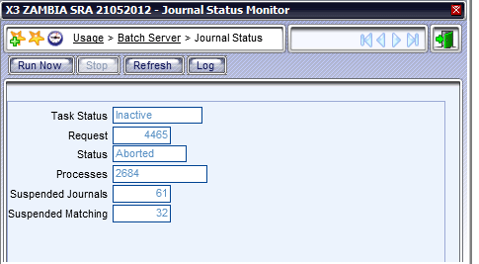
The initial status ‘Inactive’ will be changed into ‘In progress’

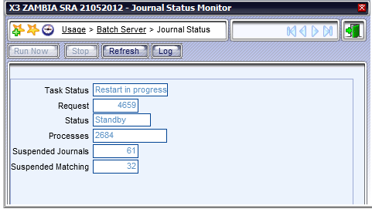
- Refresh the batch

